Using the DHT11 temperature and humidity sensor:

<http://www.circuitbasics.com/how-to-set-up-the-dht11-humidity-sensor-on-the-raspberry-pi/>

Parts:

* 3 pin dht11 sensor
* Raspberry Pi
* Small motor

Steps:

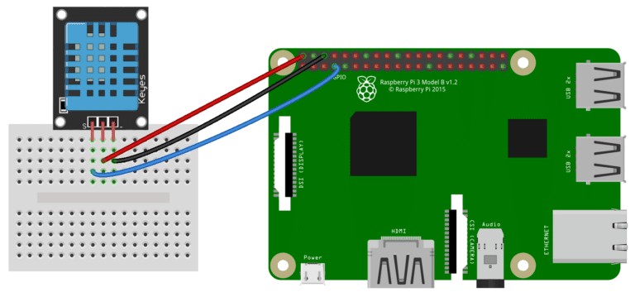

We’ll be using the Adafruit DHT11 Python library. You can download the library using Git, so if you don’t have Git installed on your Pi already, enter this at the command prompt:

sudo apt-get install git-core

Note: If you get an error installing Git, run sudo apt-get update and try it again.

To install the Adafruit DHT11 library:

1. Enter this at the command prompt to download the library:

git clone https://github.com/adafruit/Adafruit_Python_DHT.git

2. Change directories with: cd Adafruit_Python_DHT

3. Now enter this: sudo apt-get install build-essential python-dev

4. Then install the library with: sudo python setup.py install

How the sensor works:

Source: <https://www.quora.com/How-does-DHT-11-sensor-work-how-is-humidity-sensed-by-its-sensor-working-material-used-and-temperature>

The DHT sensors can measure both temperature and humidity.

The temperature is measured with the help of a NTC thermistor or negative temperature coefficient thermistor. These thermistors are usually made with semiconductors, ceramic and polymers. The resistance of the device is inversely proportional with temperature and follows a hyperbolic curve. Temperature using NTC often found out Steinhart Hart equation. You can search for the equation over Google.

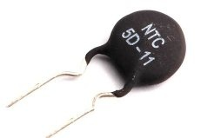

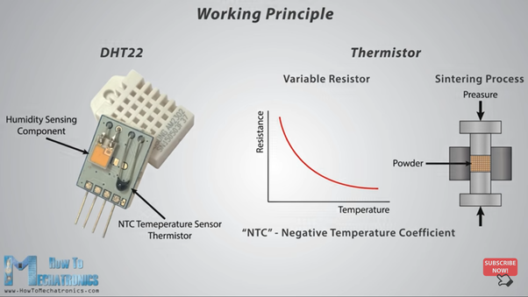

The humidity is sensed using a moisture dependent resistor. It has two electrodes and in between them there exist a moisture holding substrate which holds moisture. The conductance and hence resistance changes with changing humidity.

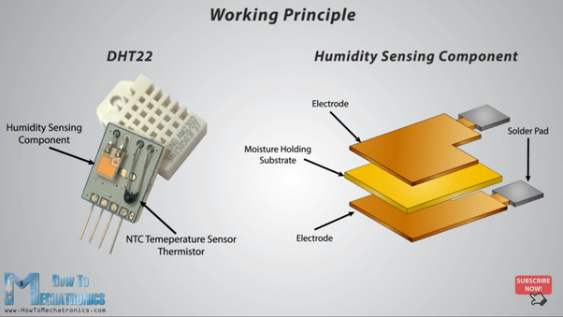

Both these temperatures and humidity a changes are processed by an IC placed on the other side of the board. It calculates the values of both and can transmit those values to a microcontroller using only a single data line.